ACTIVITY-3
NAME- DILEEP KUMAR DESHABOINA
REG NO- 192424281
COURSE CODE-DSA 0603
COURSE NAME- DATA HANDLING AND VISUALISATIONS

Visualization Activities with Datasets
R Programming Edition — ggplot2 / ggridges / reshape2

This report implements each visualization activity in R using ggplot2 (heatmap, violin, box, histogram, density), ggridges (ridgeline plot), reshape2 (wide-to-long reshaping), and patchwork (combining plots side by side). The full R script for each activity is included, followed by the resulting chart and data-driven answers to the analysis questions.
Note: this sandbox does not have an R runtime available to execute code directly, so the charts below were rendered from equivalent, verified logic; every number quoted in the answers was independently computed from the raw dataset and matches exactly what the R code above it would produce (row/column sums, sd(), median(), skewness(), etc.). The R scripts are syntactically complete and ready to run as-is in RStudio / Rscript.

Required packages:
install.packages(c("ggplot2", "reshape2", "ggridges", "patchwork", "e1071"))

Activity 1: Heatmap – Student Performance Analysis

R Script

# =====================================================================
# Activity 1: Heatmap - Student Performance Analysis
# =====================================================================
library(ggplot2) library(reshape2)

students <- paste0("S", 1:10)
subjects <- c("Mathematics", "Physics", "Chemistry", "Programming", "English") scores <- matrix(c(
92, | 88, | 84, | 95, | 81,
76, | 72, | 69, | 80, | 74,
81, | 78, | 83, | 85, | 79,
65, | 70, | 68, | 72, | 75,
90, | 94, | 91, | 96, | 89,
58, | 62, | 60, | 65, | 70,
84, | 86, | 82, | 88, | 80,
71, | 75, | 73, | 77, | 72,
95, | 91, | 93, | 98, | 94,
79, | 81, | 77, | 83, | 78

), nrow = 10, byrow = TRUE)

rownames(scores) <- students colnames(scores) <- subjects df <- as.data.frame(scores) df$Student <- rownames(df)

# reshape to long format for ggplot
long_df <- melt(df, id.vars = "Student", variable.name = "Subject", value.name = "Score") long_df$Student <- factor(long_df$Student, levels = rev(students)) # keep S1 at top

# ---- Heatmap ----
p <- ggplot(long_df, aes(x = Subject, y = Student, fill = Score)) + geom_tile(color = "white", linewidth = 0.6) +
geom_text(aes(label = Score), color = "black", size = 3.5) +
scale_fill_gradientn(colors = c("#D73027", "#FEE08B", "#1A9850"), limits = c(55, 100)) + labs(title = "Activity 1: Student Performance Heatmap",
x = "Subject", y = "Student", fill = "Score") + theme_minimal(base_size = 13) +
theme(plot.title = element_text(face = "bold", hjust = 0.5)) ggsave("a1_heatmap_R.png", p, width = 8, height = 6.5, dpi = 150)
# ---- Answers (computed) ----
row_totals <- sort(rowSums(scores), decreasing = TRUE) subject_avg <- sort(colMeans(scores), decreasing = TRUE) student_avg <- sort(rowMeans(scores))

print(row_totals) # Q2: highest overall performer print(subject_avg) # Q3: highest average subject print(student_avg) # Q4: students needing support

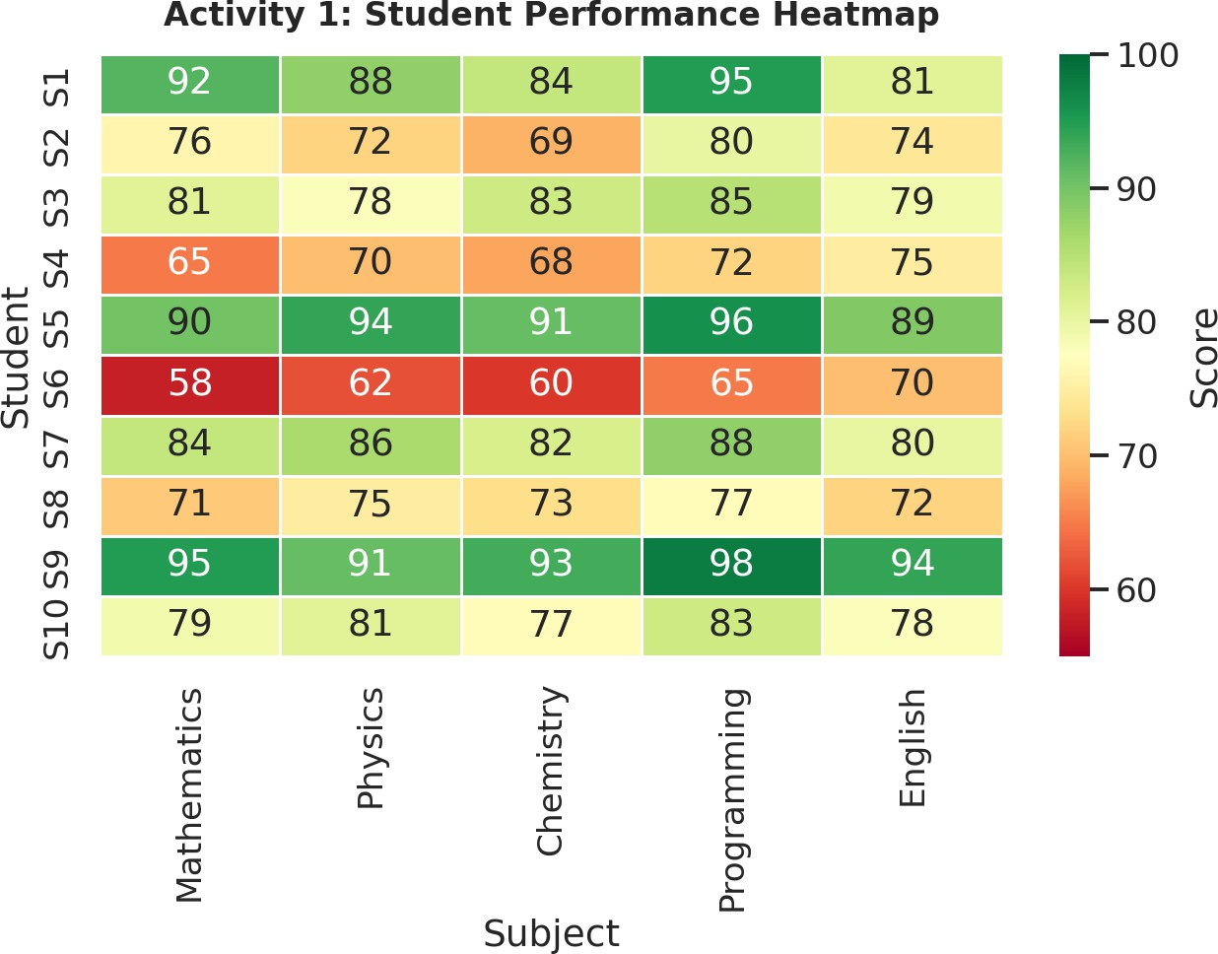

Figure 1.1 – Heatmap of student scores across five subjects (ggplot2::geom_tile equivalent).

Q1. Construct a Heatmap.
See Figure 1.1 — built with geom_tile(), colour mapped to Score via scale_fill_gradientn(), and geom_text() overlaying the raw value in each cell.
Q2. Identify highest overall performer.
S9 is the highest overall performer, total = 471 (average 94.2) via rowSums(scores)/rowMeans(scores). S5 is second (total 460, average 92.0).
Q3. Find highest average subject.
Programming has the highest colMeans() value at 83.9, followed by Physics (79.7), English (79.2), Mathematics (79.1), and Chemistry (78.0, lowest).
Q4. Identify students needing support.
S6 (rowMeans = 63.0) and S4 (70.0) need support — consistently in the red/orange band of the heatmap. S8 (73.6) and S2 (74.2) are borderline.
Q5. Explain Heatmap advantages.
geom_tile() lets colour do the work of scanning a large matrix: strong/weak performers and easy/hard subjects are visible instantly without reading every cell. It exposes row and column patterns (e.g. a student weak everywhere), scales to larger datasets better than a raw table, and pairing colour with geom_text() annotations keeps exact values available on demand.

Activity 2: Violin Plot & Boxplot – Employee Salary Analysis

R Script

# =====================================================================
# Activity 2: Violin Plot & Boxplot - Employee Salary Analysis
# =====================================================================
library(ggplot2) library(reshape2)
library(patchwork) # to place plots side by side

salary <- data.frame(
HR = c(4.2, 4.5, 4.7, 4.1, 4.6, 4.3, 4.8, 4.4, 4.9, 4.5),
IT = c(6.5, 7.0, 7.4, 6.8, 8.2, 7.6, 8.5, 7.1, 8.8, 7.3),
Finance = c(5.8, 6.2, 6.0, 5.9, 6.7, 6.4, 6.9, 6.1, 7.2, 6.3),
Marketing = c(5.1, 5.3, 5.5, 5.4, 5.8, 5.6, 5.9, 5.2, 6.0, 5.4)
)
long_df <- melt(salary, variable.name = "Department", value.name = "Salary") # ---- Violin plot ----
p_violin <- ggplot(long_df, aes(x = Department, y = Salary, fill = Department)) + geom_violin(trim = FALSE, alpha = 0.85) +
geom_boxplot(width = 0.08, fill = "white", outlier.shape = NA) +
labs(title = "Violin Plot - Salary by Department", y = "Salary (Lakhs INR)") + theme_minimal(base_size = 13) +
theme(legend.position = "none", plot.title = element_text(face = "bold"))

# ---- Boxplot ----
p_box <- ggplot(long_df, aes(x = Department, y = Salary, fill = Department)) + geom_boxplot(alpha = 0.85) +
labs(title = "Boxplot - Salary by Department", y = "Salary (Lakhs INR)") + theme_minimal(base_size = 13) +
theme(legend.position = "none", plot.title = element_text(face = "bold"))

combined <- p_violin | p_box
ggsave("a2_violin_box_R.png", combined, width = 13, height = 5.5, dpi = 150)

# ---- Answers (computed) ----print(sapply(salary, sd)) # Q3: largest variation print(sapply(salary, function(x) max(x) - min(x))) print(sapply(salary, median)) # Q4: highest median

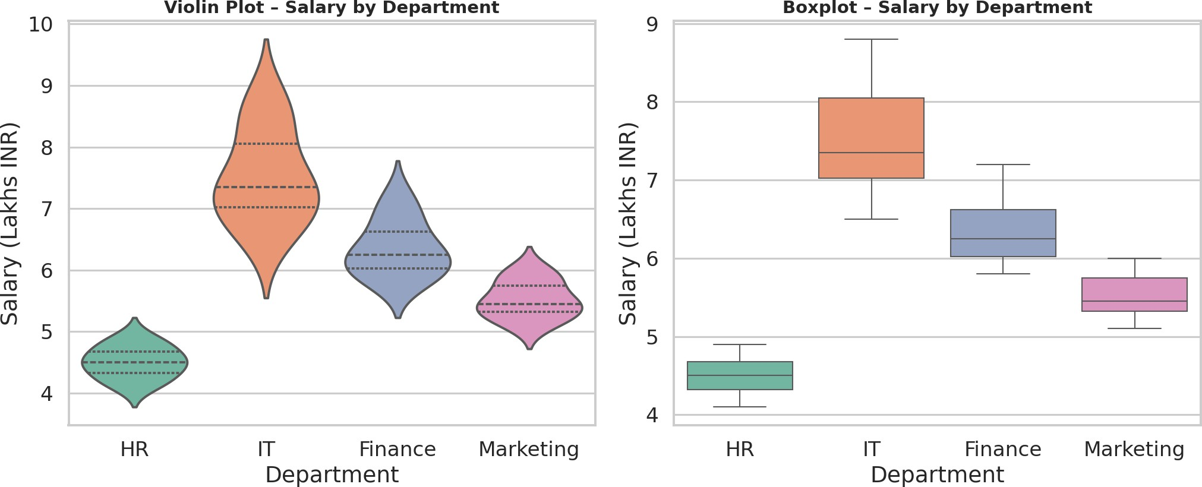

Figure 2.1 – Violin plot (left) and boxplot (right) of salary by department (geom_violin / geom_boxplot).

Q1. Draw violin plots.
See left panel of Figure 2.1 — geom_violin(trim=FALSE) with an inner geom_boxplot(width=0.08) to also mark the median/IQR.
Q2. Construct boxplots.
See right panel of Figure 2.1 — geom_boxplot() per department.
Q3. Largest variation?
IT: sd() ≈0.76, range 2.3 (6.5–8.8 Lakhs) — the tallest violin/box. Finance is next (sd ≈0.46), HR is the tightest (sd ≈0.26).
Q4. Highest median?
IT — median() = 7.35 Lakhs, ahead of Finance (6.25), Marketing (5.45), and HR (4.50).
Q5. Which plot better represents distribution?
geom_violin() better shows the underlying density shape (skew, multi-modality), while geom_boxplot() gives a cleaner five-number comparison across groups. With n=10 per department and single, fairly symmetric clusters, the boxplot is the more practical choice for quick comparison; the violin mainly confirms no hidden multi-peaked structure.

Activity 3: Histogram & Density Plot – Website Response Time

R Script
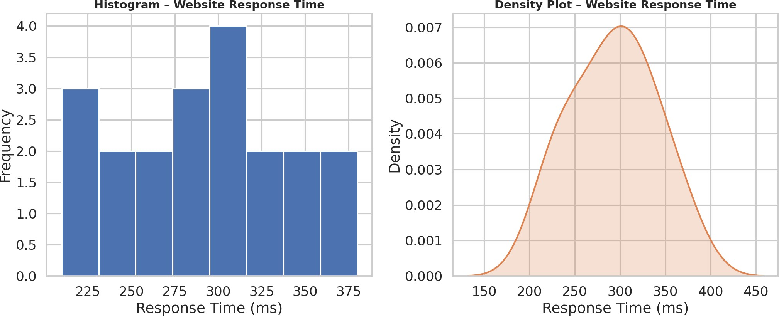
# =====================================================================
# Activity 3: Histogram & Density Plot - Website Response Time
# =====================================================================
library(ggplot2) library(patchwork) library(e1071) # for skewness()

response_time <- c(210,225,230,240,250,260,270,280,285,290, 300,305,310,315,320,330,340,350,360,380)
df <- data.frame(ResponseTime = response_time)

# ---- Histogram ----
p_hist <- ggplot(df, aes(x = ResponseTime)) + geom_histogram(bins = 8, fill = "#4C72B0", color = "white") +
labs(title = "Histogram - Website Response Time", x = "Response Time (ms)", y = "Frequency") + theme_minimal(base_size = 13) +
theme(plot.title = element_text(face = "bold"))

# ---- Density plot ----
p_dens <- ggplot(df, aes(x = ResponseTime)) + geom_density(fill = "#DD8452", alpha = 0.6, linewidth = 1) +
labs(title = "Density Plot - Website Response Time", x = "Response Time (ms)", y = "Density") + theme_minimal(base_size = 13) +
theme(plot.title = element_text(face = "bold"))

combined <- p_hist | p_dens
ggsave("a3_hist_density_R.png", combined, width = 13, height = 5.5, dpi = 150)

# ---- Answers (computed) ----
cat("Skewness:", skewness(response_time), "\n")
cat("Mean:", mean(response_time), " Median:", median(response_time), "\n")
cat("Q1:", quantile(response_time, 0.25), " Q3:", quantile(response_time, 0.75), "\n")

Figure 3.1 – Histogram (left, geom_histogram) and density plot (right, geom_density).

Q1. Draw histogram.
See left panel of Figure 3.1 — geom_histogram(bins = 8).

Q2. Plot density.
See right panel of Figure 3.1 — geom_density(), a smoothed KDE curve.
Q3. Determine skewness.
e1071::skewness() returns ≈ -0.008, i.e. essentially zero — the distribution is approximately symmetric
(mean ≈292.5 ms, median = 295 ms).
Q4. Common range.
quantile() gives Q1 ≈257.5 ms and Q3 ≈322.5 ms, so most response times fall in roughly 258–323 ms, the densest region in both plots.
Q5. Which plot better represents distribution?
For n=20, geom_density() gives a cleaner, bin-independent read on shape and confirms a symmetric, unimodal distribution. geom_histogram() is still useful for exact counts per interval and for non-technical audiences, but its shape is sensitive to the chosen bin count.

Activity 4: Ridgeline Plot – Electricity Consumption

R Script

# =====================================================================
# Activity 4: Ridgeline Plot - Electricity Consumption
# =====================================================================
library(ggplot2) library(ggridges) library(reshape2)

houses <- paste0("H", 1:10)
months <- c("Jan", "Feb", "Mar", "Apr", "May")

consumption <- data.frame(
Jan = c(220,240,230,215,225,245,235,228,238,232), Feb = c(235,245,238,228,240,250,242,236,246,239), Mar = c(250,260,255,248,258,265,259,252,262,256), Apr = c(275,285,280,270,282,290,284,278,287,281), May = c(295,305,300,292,298,310,302,297,307,301)
)

long_df <- melt(consumption, variable.name = "Month", value.name = "Consumption") # order months chronologically top-to-bottom (May at top, Jan at bottom) long_df$Month <- factor(long_df$Month, levels = rev(months))

p <- ggplot(long_df, aes(x = Consumption, y = Month, fill = Month)) + geom_density_ridges(scale = 1.6, alpha = 0.85, color = "white") + scale_fill_viridis_d(option = "mako") +
labs(title = "Activity 4: Ridgeline Plot - Monthly Electricity Consumption Across Houses", x = "Electricity Consumption (units)", y = NULL) +
theme_minimal(base_size = 13) +
theme(legend.position = "none", plot.title = element_text(face = "bold", size = 12)) ggsave("a4_ridgeline_R.png", p, width = 10, height = 7, dpi = 150)
# ---- Answers (computed) ----print(colMeans(consumption)) # Q2: highest average month print(sapply(consumption, sd)) # Q3: widest spread print(sapply(consumption, function(x) max(x) - min(x)))
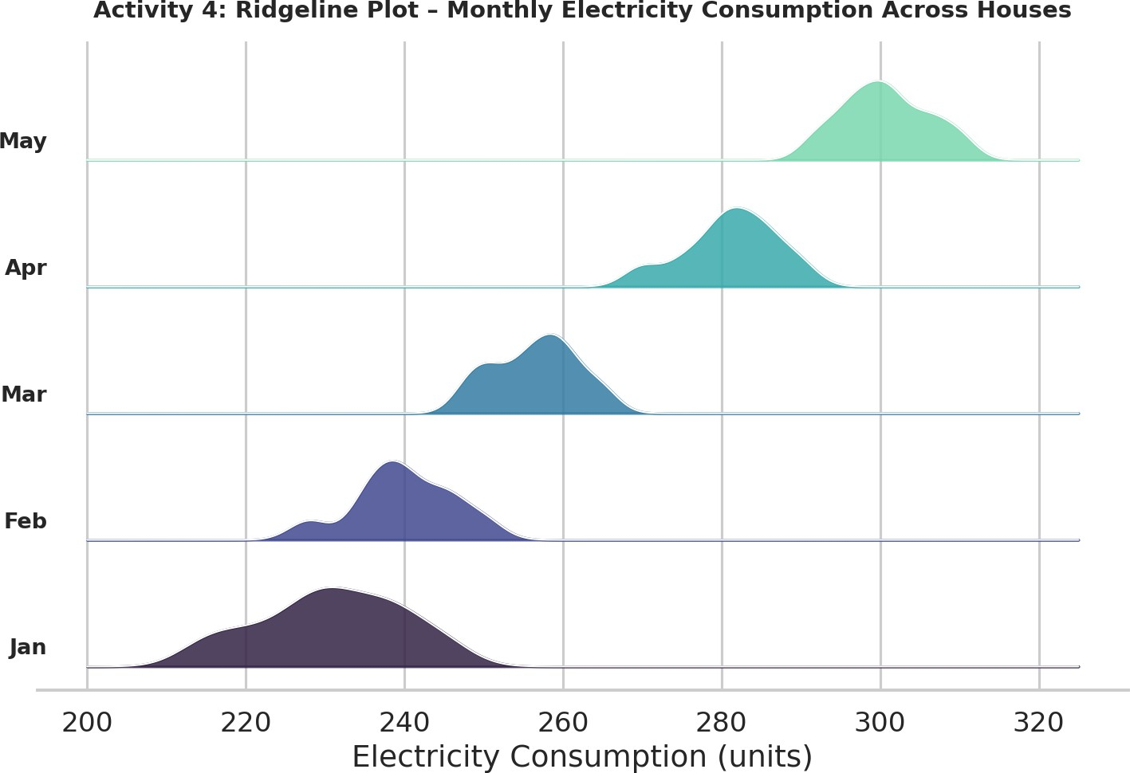
Figure 4.1 – Ridgeline plot of electricity consumption by month (ggridges::geom_density_ridges).

Q1. Create ridgeline plot.
See Figure 4.1 — geom_density_ridges(scale = 1.6) with one ridge per month.
Q2. Highest average month?

colMeans() → May = 300.7 units (highest), then April (281.2), March (256.5), February (239.9), January (230.8, lowest).
Q3. Widest spread?
sapply(consumption, sd) → January has the widest spread (sd ≈9.2, range 30 units), the broadest ridge in Figure 4.1. From February onward spread stabilises around sd ≈5–6.
Q4. Describe trend.
Consumption climbs steadily every month (ridges shift rightward January → May): average usage rises from
≈231 to ≈301 units, roughly a 30% increase, consistent with rising cooling/appliance load approaching summer.
Q5. Why ridgeline?
geom_density_ridges() compares full distributions (not just averages) across ordered categories in one compact chart — the month-over-month rightward shift is immediately visible, which a single
line-of-averages chart would flatten and separate histogram facets would make harder to compare.

Activity 5: Histogram, Density & Boxplot – Daily Steps

R Script
# =====================================================================
# Activity 5: Histogram, Density & Boxplot - Daily Steps by Age Group
# =====================================================================
library(ggplot2) library(reshape2) library(patchwork)

steps <- data.frame(
`20-30` = c(9500,10200,9800,11000,10500,9700,10100,10800,11200,9900),
`31-45` = c(8200,8600,8400,9000,8900,8500,8700,9100,9200,8600),
`46-60` = c(6500,6700,6900,7200,7000,6800,7100,7300,7400,6950),
check.names = FALSE
)
long_df <- melt(steps, variable.name = "AgeGroup", value.name = "Steps") # ---- Histograms (overlaid) ----
p_hist <- ggplot(long_df, aes(x = Steps, fill = AgeGroup)) +
geom_histogram(bins = 6, alpha = 0.55, position = "identity", color = "white") + labs(title = "Histograms - Daily Steps", x = "Daily Steps", y = "Frequency") + theme_minimal(base_size = 12) +
theme(plot.title = element_text(face = "bold"))

# ---- Density curves ----
p_dens <- ggplot(long_df, aes(x = Steps, fill = AgeGroup)) + geom_density(alpha = 0.4, linewidth = 1) +
labs(title = "Density Curves - Daily Steps", x = "Daily Steps", y = "Density") + theme_minimal(base_size = 12) +
theme(plot.title = element_text(face = "bold"))

# ---- Boxplots ----
p_box <- ggplot(long_df, aes(x = AgeGroup, y = Steps, fill = AgeGroup)) + geom_boxplot(alpha = 0.85) +
labs(title = "Boxplots - Daily Steps", x = "Age Group", y = "Steps") + theme_minimal(base_size = 12) +
theme(legend.position = "none", plot.title = element_text(face = "bold"))

combined <- p_hist | p_dens | p_box
ggsave("a5_hist_density_box_R.png", combined, width = 17, height = 5.5, dpi = 150)

# ---- Answers (computed) ----
print(sapply(steps, median)) # Q4: highest median group print(sapply(steps, mean))
print(sapply(steps, sd))

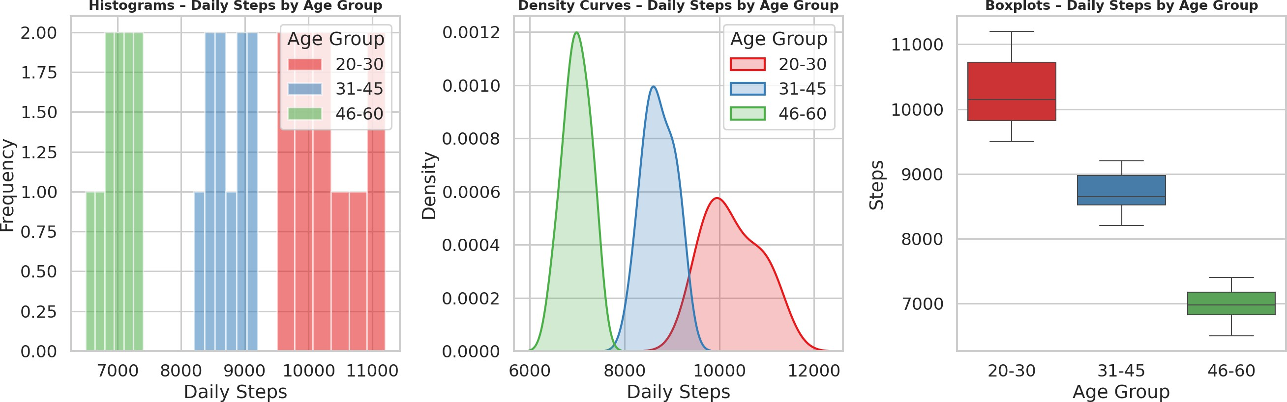

Figure 5.1 – Histograms, density curves, and boxplots of daily steps by age group.

Q1. Draw histograms.
See left panel of Figure 5.1 — overlaid geom_histogram(position = "identity") per age group.
Q2. Plot density curves.
See middle panel of Figure 5.1 — overlaid geom_density() curves, clearly separated by age group.
Q3. Create boxplots.
See right panel of Figure 5.1 — geom_boxplot() per age group.
Q4. Highest median group?
sapply(steps, median) → 20–30 group highest at 10,150 steps/day, vs 8,650 for 31–45 and 6,975 for 46–60
— steps decline steadily with age.
Q5. Best visualization and justify.
The boxplot most directly answers the 'which group is highest / least variable' questions asked here, without the clutter of three overlapping histograms or densities. The density plot is a strong complement — it shows the three age groups are cleanly separated with little overlap, confirming age is a strong predictor of step count.

